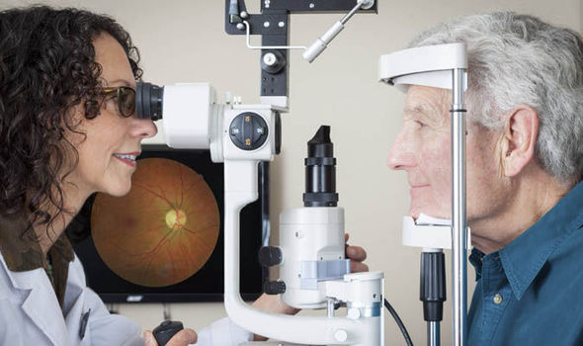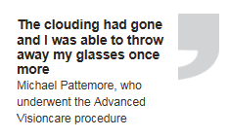

Michael, who was married to the actress and broadcaster Lynda Bellingham who lost her battle with cancer last October aged 66, says: “I began to notice that when I read I couldn’t see the text as well as normal.

“It started out as a sort of clouding which I passed off as my previous laser eye surgery ‘wearing off’. But by January this year it had got to the point that I couldn’t ignore it any more. It was there all the time and I couldn’t blink it away.

“I began needing brighter and brighter lights to be able to make out the words in books.”

After visiting an ophthalmologist at the Advanced Visioncare clinic on London’s Harley Street, the 59-year-old mortgage broker from north London discovered he had cataracts in both eyes and was given an opportunity to have a new high-tech laser procedure to restore his vision.

Cataracts are cloudy patches that develop in the lens of the eye, causing blurred or misty vision as light is prevented from reaching the back of the eye.

The new technology has made cataract surgery a less invasive and safer experience for patient

By [Hannah Britt](http://www.express.co.uk/search/Hannah+Britt?s=Hannah+Britt&b=1)

PUBLISHED: 13:33, Tue, Sep 1, 2015 | UPDATED: 14:01, Tue, Sep 1, 2015

**My cataracts were gone in minutes: The technology that's giving people their sight back**

**IT WAS in the months following his wife’s death that Michael Pattemore began to notice that his eyesight was deteriorating.**

It is a very common condition which around 720,000 people are diagnosed with every month and it is estimated that half of people over the age of 65 have cataracts in both eyes.

The clouding had gone and I was able to throw away my glasses once more

Michael Pattemore, who underwent the Advanced Visioncare procedure

Too much sunshine, smoking and a family history of the condition increase the odds of developing problems and studies have suggested that statins may also raise the risk.

If cataracts are mild, stronger glasses may be prescribed and brighter reading lights may be helpful for some time.

However, as cataracts get worse over time the only way to restore sight is to cut into the membrane protecting the eye to remove the damaged lens and replace it with an artificial one.

Conventional surgery involves a small cut into the surface of the eye and using an ultrasound probe to break up and remove the damaged lens.

Although it is generally regarded as being a safe procedure – it is the most common operation performed worldwide – there are risks.

If the surgeon accidentally tears the eye’s delicate membrane and that tear goes out or cuts through the lens, complications due to infection and inflammation can occur.

Newer procedures use computer imaging to guide the laser which reduces risks of tears and allows the surgeon to create a perfect circle to hold a new lens.

However the latest technology which was previously only available in America, uses a machine called the Centurion Vision System and Verion Image Guided System.

The procedures uses digital imagery to tell the surgeons precisely where the incision should be made and automatically controls the pressure dynamics in the eye during surgery, significantly reducing the risk of chronic swelling, soreness and increased pressure inside the eye afterwards.

“This technology represents the future of eye cataract surgery and is the safest yet,” says Mr Chidambara Pillai, the medical director of the Advanced Visioncare clinic which is offering the new system.

“It enables the stability of the eye during complicated manoeuvres in cataract surgery.”

So far the clinic has carried out 15 procedures using the new technology.

“For the patient it means a less invasive experience with faster recovery times, allowing them to return back to their everyday routine,” more quickly says Mr Pillai.

Michael had the procedure at the end of June.

“To be perfectly honest, I was really scared,” he admits.

“But I never felt a thing. The nurse put drops into my eyes and gave me a sedative to calm me down. Mr Pillai explained to me that all I would see during the procedure was a great deal of coloured light.”

One of the advantages of replacing the natural lens with an artificial one is the patient is left with perfect vision for both distance and reading and will no longer need glasses or contact lenses if they did so before.

“More and more people from the age of 45 are choosing to have cataract treatment as lifestyles have changed and people are more active in their later years,” adds Mr Pillai.

“They want perfect vision for both distance and reading, without the need for varifocal glasses or contact lenses.”

Michael’s operation took around 30 minutes and he was even able to leave the clinic and attend a charity event that evening.

“I noticed the difference immediately,” he says. “The clouding had gone and I was able to throw away my glasses once more.

Michael's vision deteriorated quickly after the death of his wife, Lynda Bellingham