GCR SCORE 4.06 (HIGHEST IN NORTH INDIA)
VOTED AS NO 1 CLINIC IN NORTH INDIA IN CUSTOMER SATISFACTION.

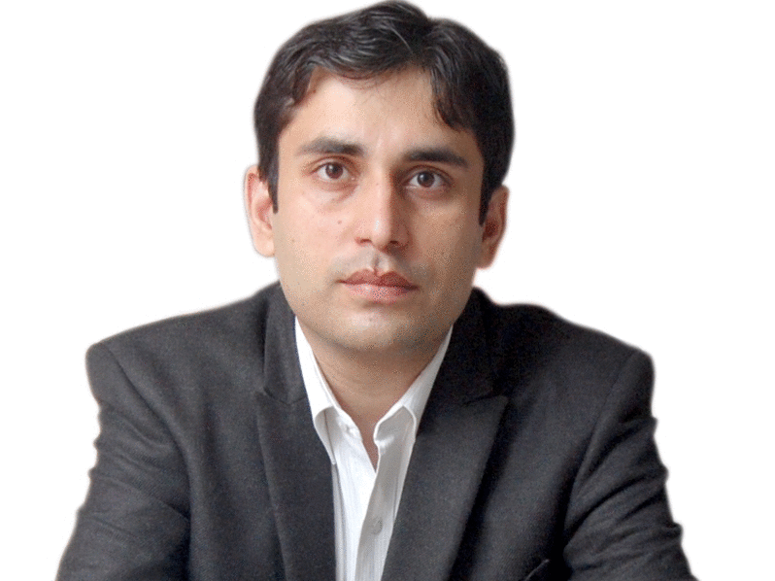

Dr Mohit Dhawan
M.D.S( Prosthodontics &Implantology) F.I.C.O.I (USA), M.A.O.I
Dr.Mohit Dhawan post graduated in forte of the Prosthetic dentistry from Pt. B.D. Sharma Health University, Rohtak. He completed “Advanced Implantology Clinical Programme” in Ziest, Holland under Prof. Dr R.C. Hertel and received advanced training in Oral Implantology at various other Clinics and centers for Implantology. He is a Life member of International Team Of Implantology, Life Member of Academy of Oral Implantology, Active Member of Academy of Osseointegration (U.S.A), a Fellow of International Congress of Oral Implantology (U.S.A),Life Member South Asian Academy of Osseointegration , Life Member Academy of Oral Implantology of India. He is first dentist from Punjab, Haryana and Chandigarh region to become an expert panelist for Oral B India. He maintains a private practice in Chandigarh Exclusively for Prosthetic, Implant dentistry and Full Mouth Rehabilitation.

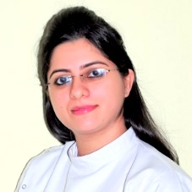

DR. ROSY ARORA

MDS (Conservative Dentistry & Endodontics)
- She has post-graduated- M.D.S (Conservative Dentistry & Endodontics) in 2012, From Baba Farid University of Health Sciences. A Consultant Endodontist practicing at AVANCE DENTAL CARE since 2013. Her Clinic has most modern Equipments in Endodontics including Surgical Operating Microscope. She offers her services as Consultant Lecturer in the Department of Conservative Dentistry at the SDD Dental College, Panchkula, India affiliated to Pt B.D. Sharma University Of Health Sciences Rohtak, India

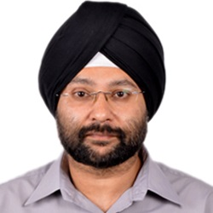

Dr. K.P.S Dhody

M.D (Anesthesia)
Dr K.P.S Dhody did his post-graduation in anesthesia from Gujarat Cancer and Research Institute, He has been a proficient Ex-Senior Resident from PGIMER Chandigarh with 11 yrs of clinical experience in handling anesthesia to Oro-Maxillo-Facial Surgeries and critical care. He is well acclaimed Expert in dental chair anesthesia And Conscious sedation. An Expert in handling geriatric and pediatrics, patients at AVANCE DENTAL CARE, India
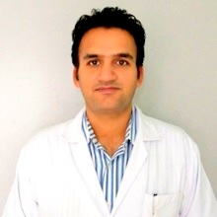
Dr. Abhishek Sharma

M.D.S (Orthodontics), WFO, AAO, IOS

Dr.Abhishek Sharma, graduated from Baba Farid University of Health Sciences, Faridkot (Punjab) and MDS from Himachal Pradesh University, Shimla (H.P). He is a active member of World Federation of Orthodontists (WFO), American Association of Orthodontists (AAO) and Indian orthodontic Society (IOS).
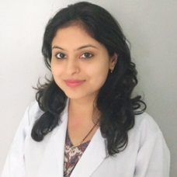

Dr. Kavita Mehta

MDS (Orthodontics)
Dr. Kavita Mehta has done her BDS and MDS from H.P. University, Shimla . She is Gold Medallist in orthodontic speciality. She is a active member of World Federation of Orthodontists (WFO), American Association of Orthodontists (AAO) and Indian orthodontic Society (IOS).
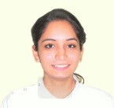

DR. SHRUTI SHARMA

Associate Dentist
Dr Shruti is a very hard working and focused part of our team. Her enthusiasm and caring nature help you feel at ease whilst in the surgery. Dr Shruti is passionate about dentistry and is always keen to learn.
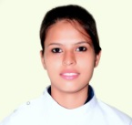

REENA RAWAT

Dental Assistant

Reena works closely with our Dental Team to enhance the patient journey beyond the dental chair! Her friendly and approachable nature goes hand in hand with her healthcare experience, making her an invaluable member of the team.
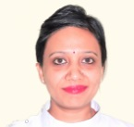

NEERJA SHARMA

Manager
Neerja is a valued member of the Avance Dental Care. She can be contacted to answer any specific questions regarding treatment, build a tailored treatment plan or to discuss financial options with different payment plans.

